The median price of residential properties increased in February 2018
ACT (original data)
The median price of all residential properties in the ACT decreased by 0.9 per cent to $530,000 in
February 2018. Through the year to February 2018, the median price of all residential properties rose by 3.9 per cent.
The average price of all residential properties in the ACT was steady (down slightly by 0.1 per cent) at $607,710 in February 2018. Through the year to February 2018, the average price of all residential properties increased by 1.7 per cent.

ACT Property Prices and Turnover, Original Data, February 2018
 |  | Level |  | Change (%)
 |  |  | Monthly |  | tty³
Houses
Median Price |  | 699,500 |  | 3.6% |  | 11.5%
Average Price |  | 785,917 |  | 5.0% |  | 9.4%
Turnover |  | 406 |  | -33.2% |  | -23.8%
Units⁴
Median Price |  | 448,000 |  | -0.4% |  | -0.2%
Average Price |  | 470,939 |  | -6.1% |  | -6.6%
Turnover |  | 529 |  | -33.5% |  | -23.3%
Total Residential
Median Price |  | 530,000 |  | -0.9% |  | 3.9%
Average Price |  | 607,710 |  | -0.1% |  | 1.7%
Turnover |  | 935 |  | -33.4% |  | -23.5%
Source: ACT Government, Access Canberra

Commentary
In February 2018, the ACT median house price increased by 3.6 per cent to $699,500, while the median unit price decreased slightly (down 0.4 per cent) to $448,000.
Over the past 5 years, in nominal terms, the median house price increased by 30.2 per cent, while the median unit price increased by 3.3 per cent.

ACT Property Prices and Turnover by District, Original Data, February 2018
District | Houses |  |  | Units
 | Median Price | Average Price | Turnover | Median Price | Average Price | Turnover
Belconnen | 626,500 | 657,090 | 87 | 449,000 | 461,008 | 101
Gungahlin | 718,500 | 702,451 | 105 | 389,950 | 395,032 | 97
Molonglo Valley | 860,000 | 830,357 | 7 | 429,900 | 441,174 | 25
North Canberra | 1,100,000 | 1,134,621 | 29 | 484,000 | 511,331 | 172
South Canberra | 1,235,000 | 1,351,083 | 35 | 480,000 | 585,064 | 55
Tuggeranong | 570,000 | 594,400 | 85 | 379,000 | 385,144 | 43
Weston Creek | 742,500 | 835,714 | 28 | 495,000 | 508,833 | 6
Woden | 858,500 | 940,993 | 30 | 354,500 | 449,194 | 30
Source: ACT Government, Access Canberra
Growth in Median Prices of All Residential Properties, ACT, Original Data

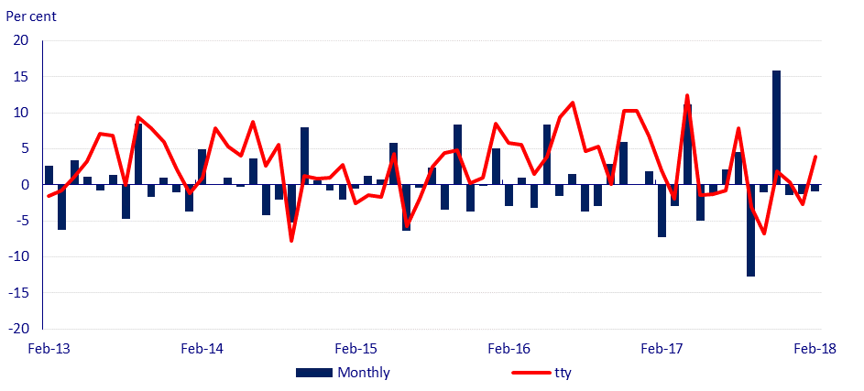
Source: ACT Government, Access Canberra

Turnover for All Residential Properties, Median House Price and Median Unit Price, ACT, Original Data

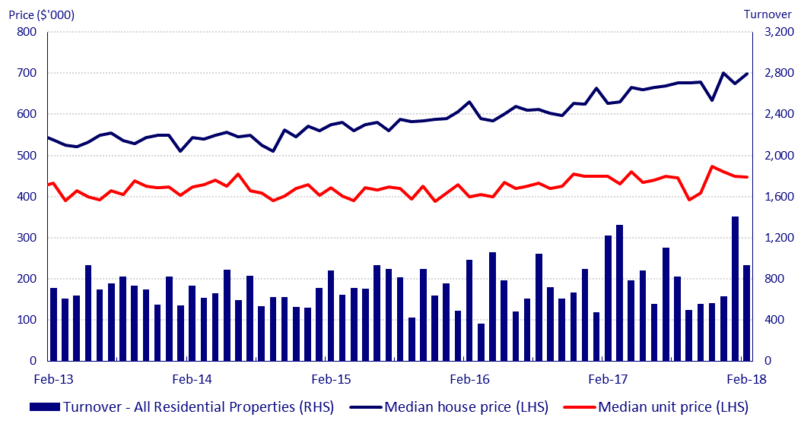
Source: ACT Government, Access Canberra

This brief is based on sales transaction data collected by the ACT Government. This data is in original terms, meaning that this data may be volatile and may be subject to seasonal and irregular factors. As such, original data should be interpreted with caution.
Median, rather than average prices, are considered to be a more representative measure for the property market, as the average can be skewed by a small number of outliers.
Through the year (tty) is the percentage change from the same period in the previous year.
Houses refer to detached dwellings; Units include townhouses, apartments, duplexes and other non-detached dwellings.

